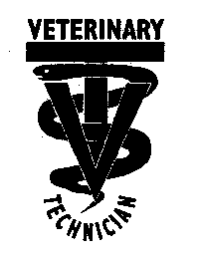
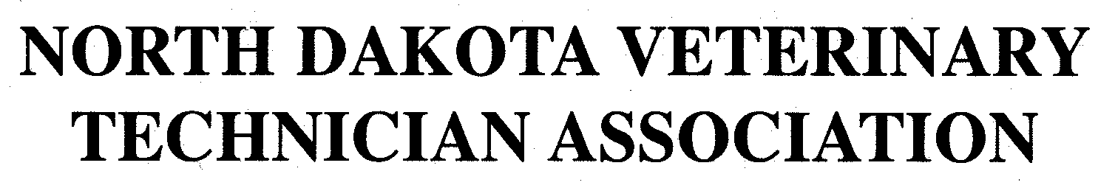
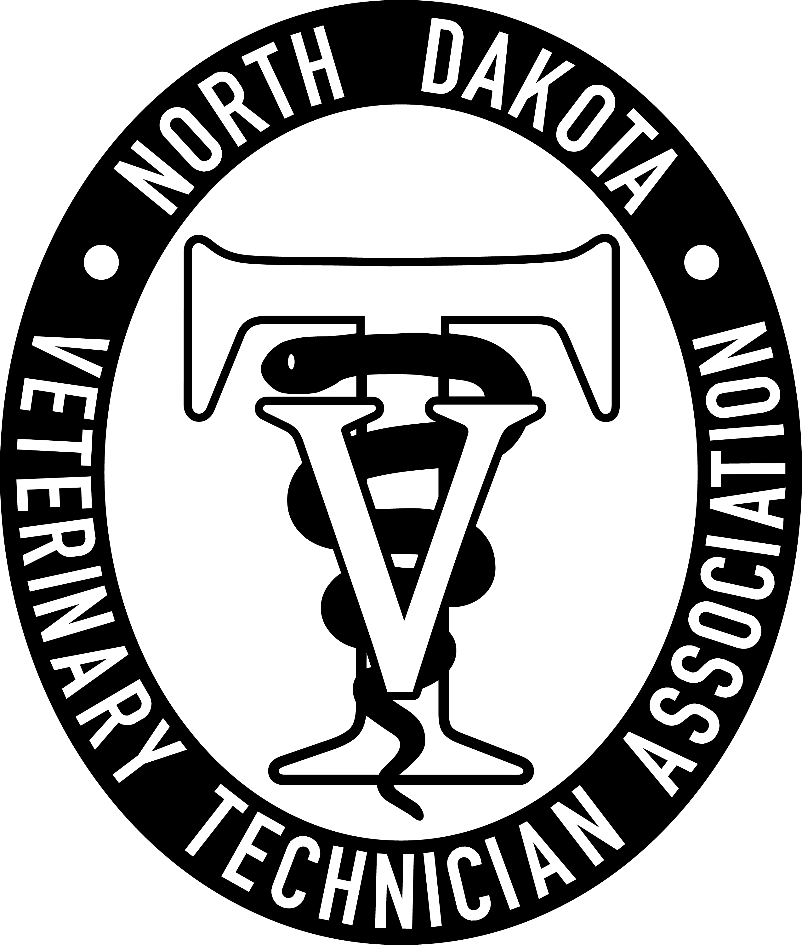

January 8, 2026, NDVTA meeting minutes
Meeting called to order by President Jessica Kuntz at 7:02 pm on January 8, 2026 via Zoom.

Attendance: Jess Kuntz/President, Bree Charmichiel/Past-President, Kelsey Wirt/President Elect, Miranda Langerud/Treasurer, Ashley Hoffmann/Secretary, Liz Bouta/Social Media, Desi Hoesel

Secretary Report: Secretary report for November was submitted by Diana Johnson. No additions or corrections. Bree made a motion to approve secretary report, seconded by Kelsey. Motion passed.

Treasurer Report: Treasurer reports for September addendum, November, and December reports were submitted by Miranda Langerud. Treasurer report for September – Bree Motioned to approve the Sept deposit addendum, Kelsey seconded. The November and December reports were submitted. No additions or corrections. Ashley made a motion to approve these treasurer reports, seconded by Bree. Motion passed.

Committee Reports:
Scholarship: Kelsey will reach out to Stacey to get started with the scholarship prep.

Tech of the Year: Kelsey will look at the wording and prep.

NDVTA Achievement Award: Nothing at this time.

PR/NVTW: Looking to add any events to the calendar for the year. Fargo Public Schools job fair coming up to represent Vet Techs at.

Social Media: Continuing scheduled posts on Facebook.

Website: Board positions updated on the website. Meeting minutes section updated to 2026. Looking into what exactly we are paying for the website. Updating forms and applications. CE Speaker application form creation.

Practice Act: Next NDBVME meeting on Feb 17

CE: Reaching out to sponsors and Randi helped get the Venue at the Radisson on October 9th. Save the Date on Facebook and on the Website.

Old Businesss:
a. Executive Director - Diana Johnson vote into position: elected unanimously. 2026-2030.

b. 2026 NDVTA Constitution Updates – went over the amendments that were edited and agreed to post them.
New Business:
- Membership Postcards – Ashley will create a membership reminder postcard and send them off to the membership addresses and the business addresses.
- CE Sponsorship tier list
- Pawsitive Care Fund – April 9th. Make a basket for the auction. ~$75 basket. Ashley will make the basket when it comes time.
- President-Elect – Kelsey Wirt elected as President-Elect on October 10, 2025. Term January 1, 2026-December 31, 2028

General membership concerns: None.

Next meeting: August 21, 2026 7pm via Zoom

Adjournment: Bree motioned to adjourn the meeting. Kelsey seconded. Motion passed. The meeting adjourned at 7:57pm

Meeting Minutes submitted by Ashley Hoffmann, LVT - Secretary

