
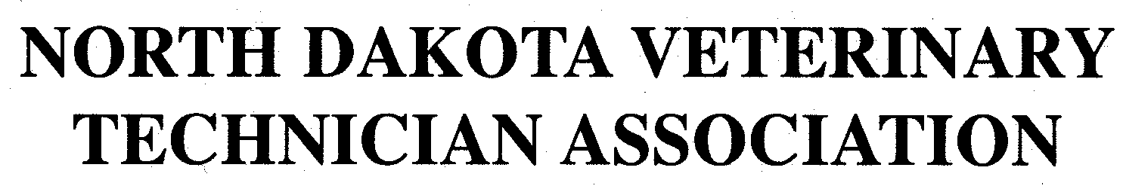
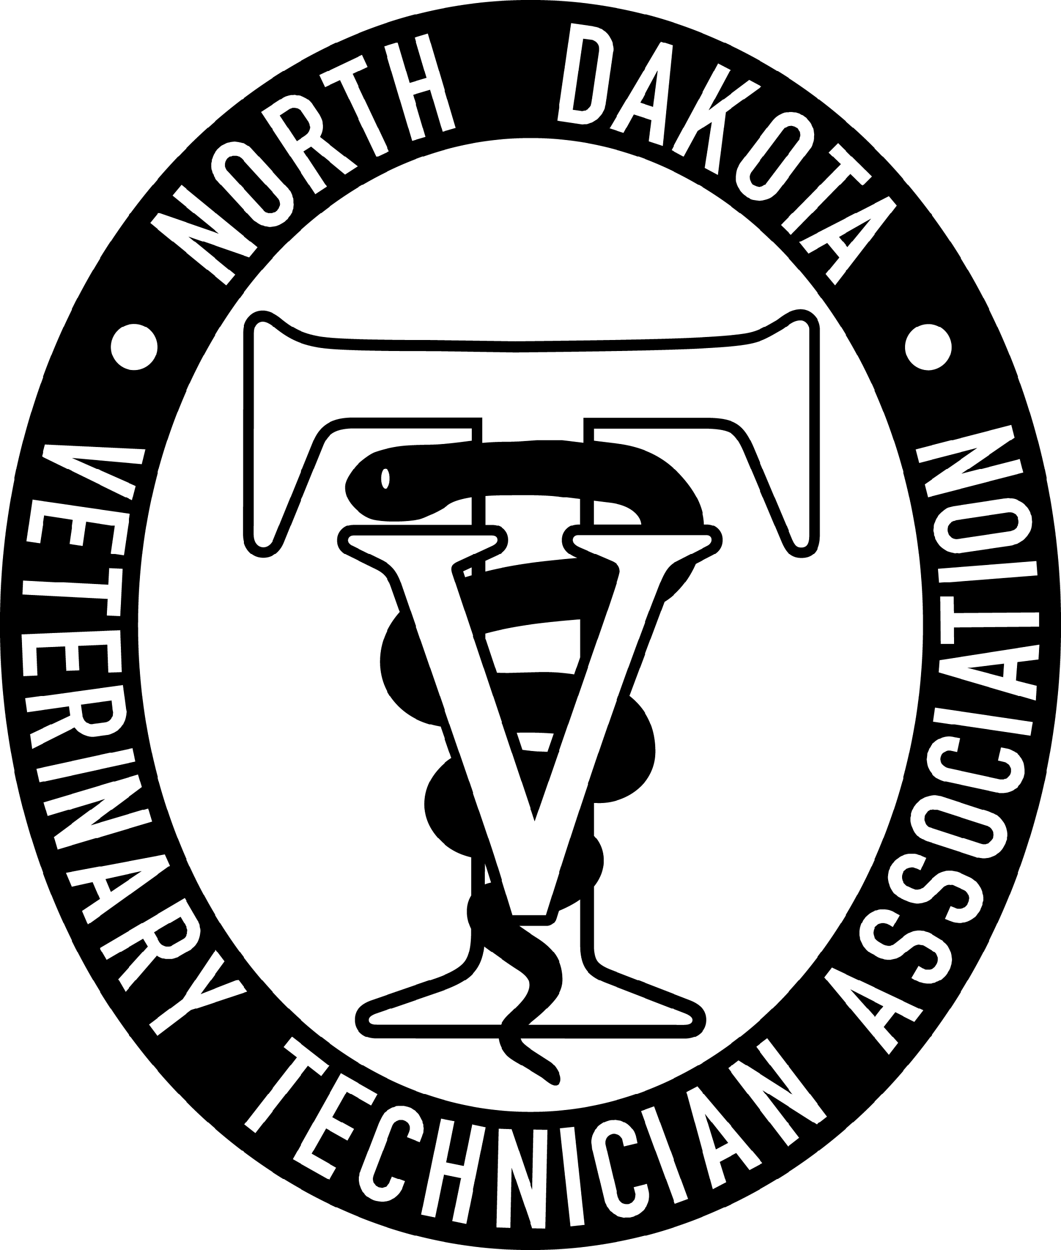

February 12, 2026, NDVTA meeting minutes
Meeting called to order by President Jessica Kuntz at 7:04 pm on February 12, 2026 via Zoom.

Attendance: Jess Kuntz/President, Bree Charmichiel/Past-President, Kelsey Wirt/President Elect, Miranda Langerud/Treasurer, Ashley Hoffmann/Secretary, Liz Bouta/Social Media, Diana Johnson/Executive Director

Secretary Report: Secretary report for January was submitted by Ashley Hoffmann. Correction – Date of next meeting was incorrect and amended. Randi made a motion to approve secretary report, seconded by Kelsey. Motion passed.

Treasurer Report: Treasurer report for January was submitted by Miranda Langerud. No additions or corrections. Bree made a motion to approve treasurer report, seconded by Kelsey. Motion passed.

Committee Reports:
Scholarship: LuAnn Lee posted to website.

Tech of the Year: Posted to the website.

NDVTA Achievement Award: Updated and posted on the website.

PR/NVTW: Pawsitive Care Fund basket – Received the form for the donation and will make a basket and drop it off. Postcard - Will send out the reminder and also email it.

Social Media: Continuing scheduled posts on Facebook.

Website: Payment function not working through the form.

Practice Act: Next NDBVME meeting on Feb 17

CE: Sponsorship tier list with titles and donation requirements.

Old Businesss:
- Website inquiries around payment processing and website maintenance. Looking to possibly switch away from Mr Multimedia and will be meeting with another company.
- Reminder postcard wording – email and send out
- CE Sponsorship tier list
- Pawsitive Care Fund Basket to be turned in this month
- President-Elect bank card– Kelsey Wirt elected as President-Elect on October 10, 2025. Term January 1, 2026-December 31, 2028.

Addition of incoming board member to the bank accounts and issue a debit card – Miranda Langerud made a motion to add Kelsey Wirt as President Elect to the bank account and to issue a debit card. Bree Carmichiel seconded the motion. Motion was voted on and passed unanimously. Miranda Langerud made a motion to allow online account access to all board members listed on the account. Ashley Hoffmann seconded. Motion was voted on and passed unanimously.

New Business:
- Tax forms – discussed different tax forms that were brought up to see if we were required to submit different papers.
- Zoom videos space will fill soon. Plan to keep only the last 11 videos on hand at any time.
- Norton Antivirus – plan to discontinue the subscription at this time as we are not using the laptop.

General membership concerns: None.

Next meeting: March 12, 2026 7pm via Zoom

Adjournment: Randi motioned to adjourn the meeting. Bree seconded. Motion passed. The meeting adjourned at 8:22pm

Meeting Minutes submitted by Ashley Hoffmann, LVT - Secretary

