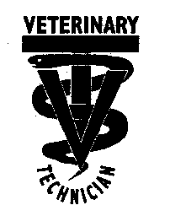
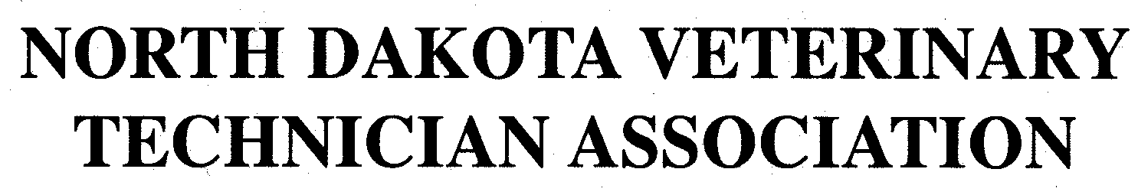
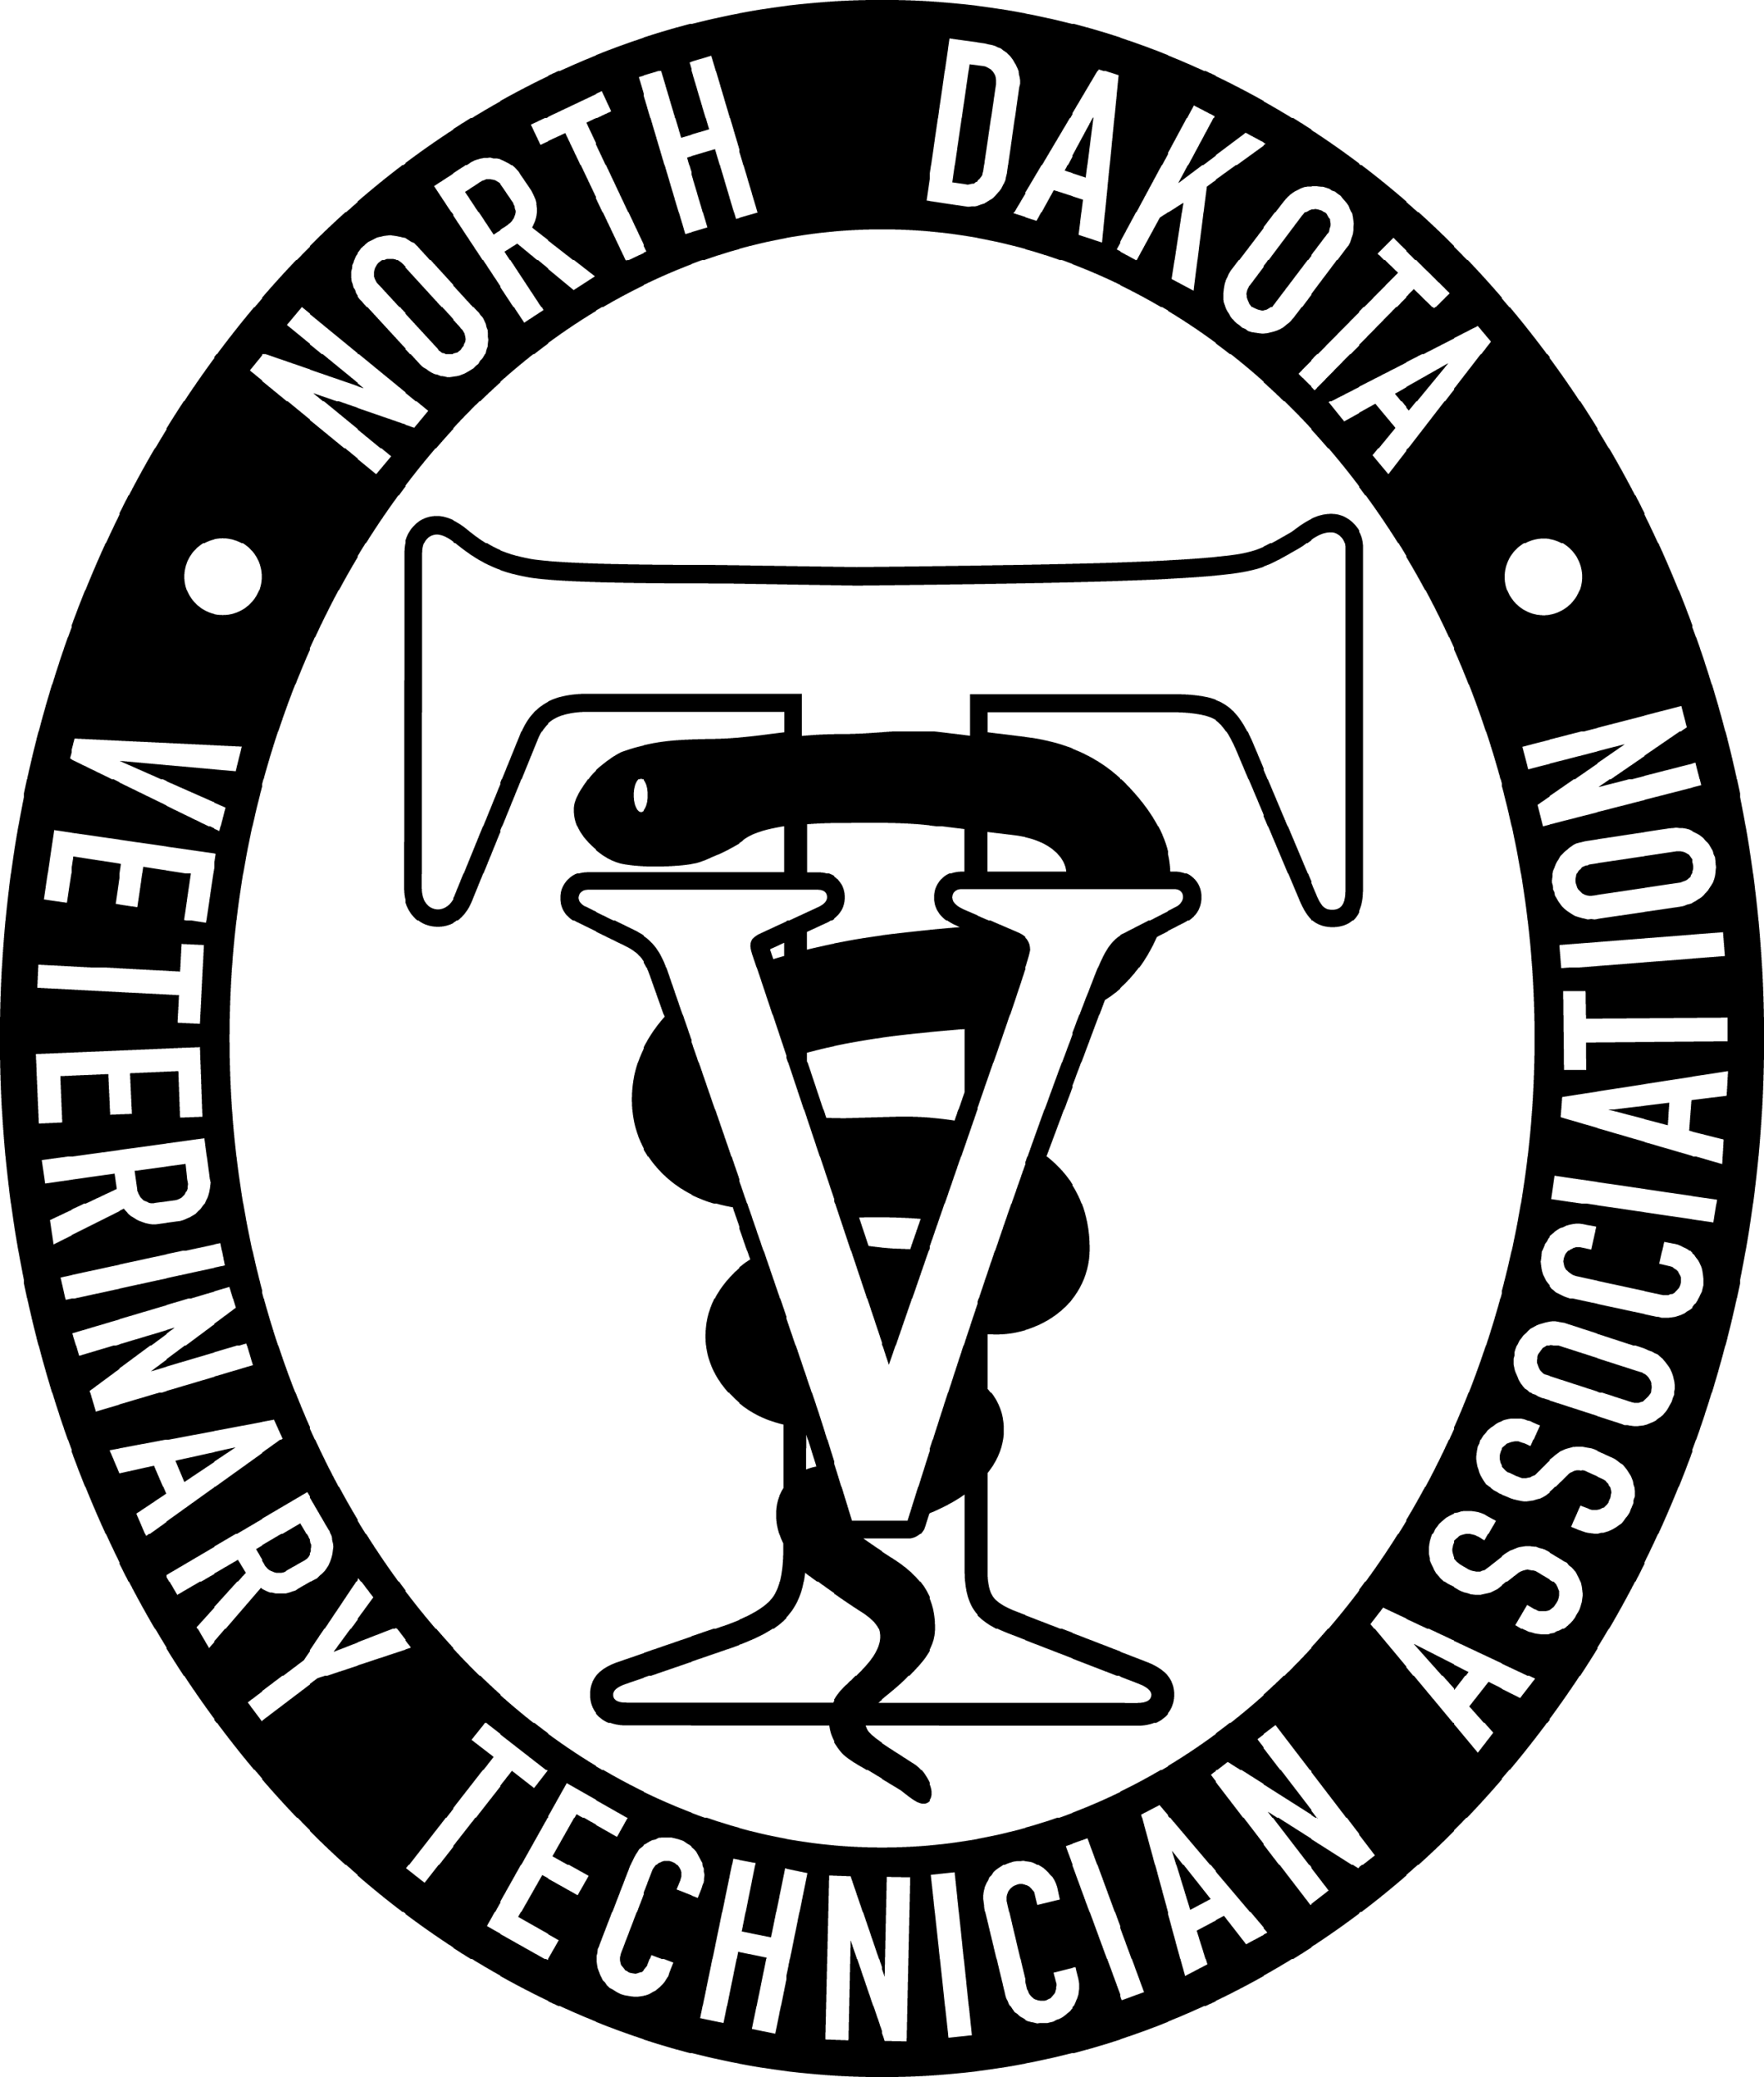

March 12, 2026, NDVTA meeting minutes
Meeting called to order by President Jessica Kuntz at 7:09 pm on March 12, 2026 via Zoom.

Attendance: Jess Kuntz/President, Bree Charmichiel/Past-President, Miranda Langerud/Treasurer, Ashley Hoffmann/Secretary, Liz Bouta/Social Media, Diana Johnson/Executive Director

Secretary Report: Secretary report for January was submitted by Ashley Hoffmann. No additions or corrections. Randi made a motion to approve secretary report, seconded by Bree. Motion passed.

Treasurer Report: Treasurer report for January was submitted by Miranda Langerud. Clarified allocation of the PR budget. Ashley made a motion to approve treasurer report, seconded by Bree. Motion passed. Made a motion to move $5,000 to the savings account.
Ashley made a motion to approve treasurer report, seconded by Bree. Motion passed.

Committee Reports:
Scholarship: LuAnn Lee posted to website.

Tech of the Year: Posted to the website.

NDVTA Achievement Award: Updated and posted on the website.

PR/NVTW: Pawsitive Care Fund basket dropped off. Looking into banner purchasing and a applique that we can put on a tablecloth.

Social Media: Continuing scheduled posts on Facebook. Possible scholarship to share.

Website: Payment function back up and running.

Practice Act: Next NDBVME meeting on June 9

CE: Sponsorship tier list with titles and donation requirements. Randi made a motion to send physical letters to veterinary practices for sponsorships. Ashley seconded. Motion passed.

Old Business:
- New Website looking into new hosts
- Bank Cards – to be sent out to them.
- Blanketed Student Discount – possible free year for new licensees as well? On hold.

New Business:
- Conference Rabies Titers - Liz

General membership concerns: None.

Next meeting: April 9, 2026 7pm via Zoom

Adjournment: Bree motioned to adjourn the meeting. Ashley seconded. Motion passed. The meeting adjourned at 7:54pm

Meeting Minutes submitted by Ashley Hoffmann, LVT - Secretary

