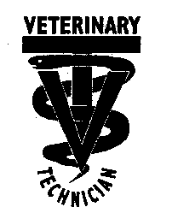

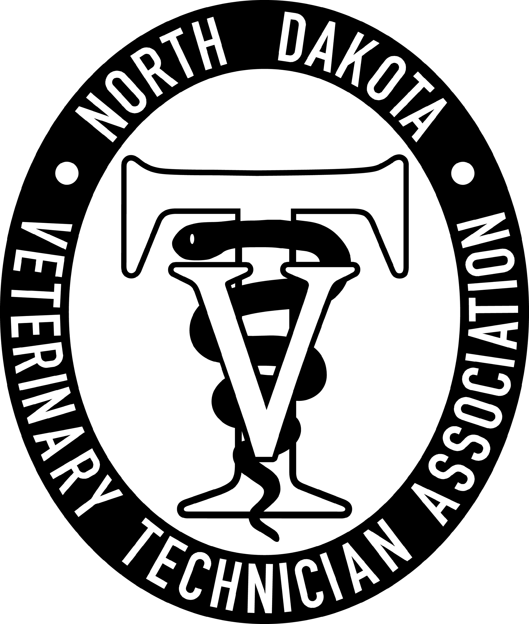

February 12, 2026, NDVTA meeting minutes
Meeting called to order by President Jessica Kuntz at 7:04 pm on April 23, 2026 via Zoom.

Attendance: Jess Kuntz/President, Kelsey Wirt/President Elect, Miranda Langerud/Treasurer, Ashley Hoffmann/Secretary, Liz Bouta/Social Media, Diana Johnson/Executive Director

Secretary Report: Secretary report for January was submitted by Ashley Hoffmann. No additions or corrections. Randi made a motion to approve secretary report, seconded by Kelsey. Motion passed.

Treasurer Report: Treasurer report for January was submitted by Miranda Langerud. No additions or corrections. Kelsey made a motion to approve treasurer report, seconded by Ashley. Motion passed.

Committee Reports:
Scholarship: LuAnn Lee posted to website and NDSU. Post on social media. No submissions yet. Questioned adding an extension on the submission window to correlate easier with the school schedule.

Tech of the Year: Posted to the website. Submission requirement possibly needs clarification as the one submission so far is not applicable.

NDVTA Achievement Award: Updated and posted on the website. No submissions.

PR/NVTW: Pawsitive Care Fund event went well, and our item was well received. Nothing new on the calendar to participate with.

Social Media: Continuing scheduled posts on Facebook.

Website: Able to export the forms on the website to Excel now.

Practice Act: NDBVME emailed out the CE requirement increase information to all technicians that will apply to the next renewal window.

CE: Rabies titer offering inquiry. Large animal speaker leads required and being looked into.

Old Businesss:
- Website inquiries around payment processing and website maintenance. Looking to possibly switch away from Mr. Multimedia and will be meeting with another company.
- Blanket Student Discount – Previously had multiple tiers of discount. Change the requirements to a single discount tier instead.
Randi made a motion to combine student and 1st year professionals to have a $10 discount on membership. Ashley seconded. Passes unanimously.

New Business:
- Conference Rabies Titers – Found a laboratory to possibly work with. Waiting for further information.
- New Technician Free Membership - Combined with Blanket Student discount discussion.
- Vet Tech verbiage on hospital websites – discussed reaching out to hospitals regarding listing VTs that are people that are not licensed being against the practice act.
- Membership quantities – need to look into the level of applications and see if based on the numbers we need to increase membership fee or CE fee possibly.

General membership concerns: None.

Next meeting: May 14, 2026 7pm via Zoom

Adjournment: Kelsey motioned to adjourn the meeting. Randi seconded. Motion passed. The meeting adjourned at 8:05pm

Meeting Minutes submitted by Ashley Hoffmann, LVT - Secretary

