

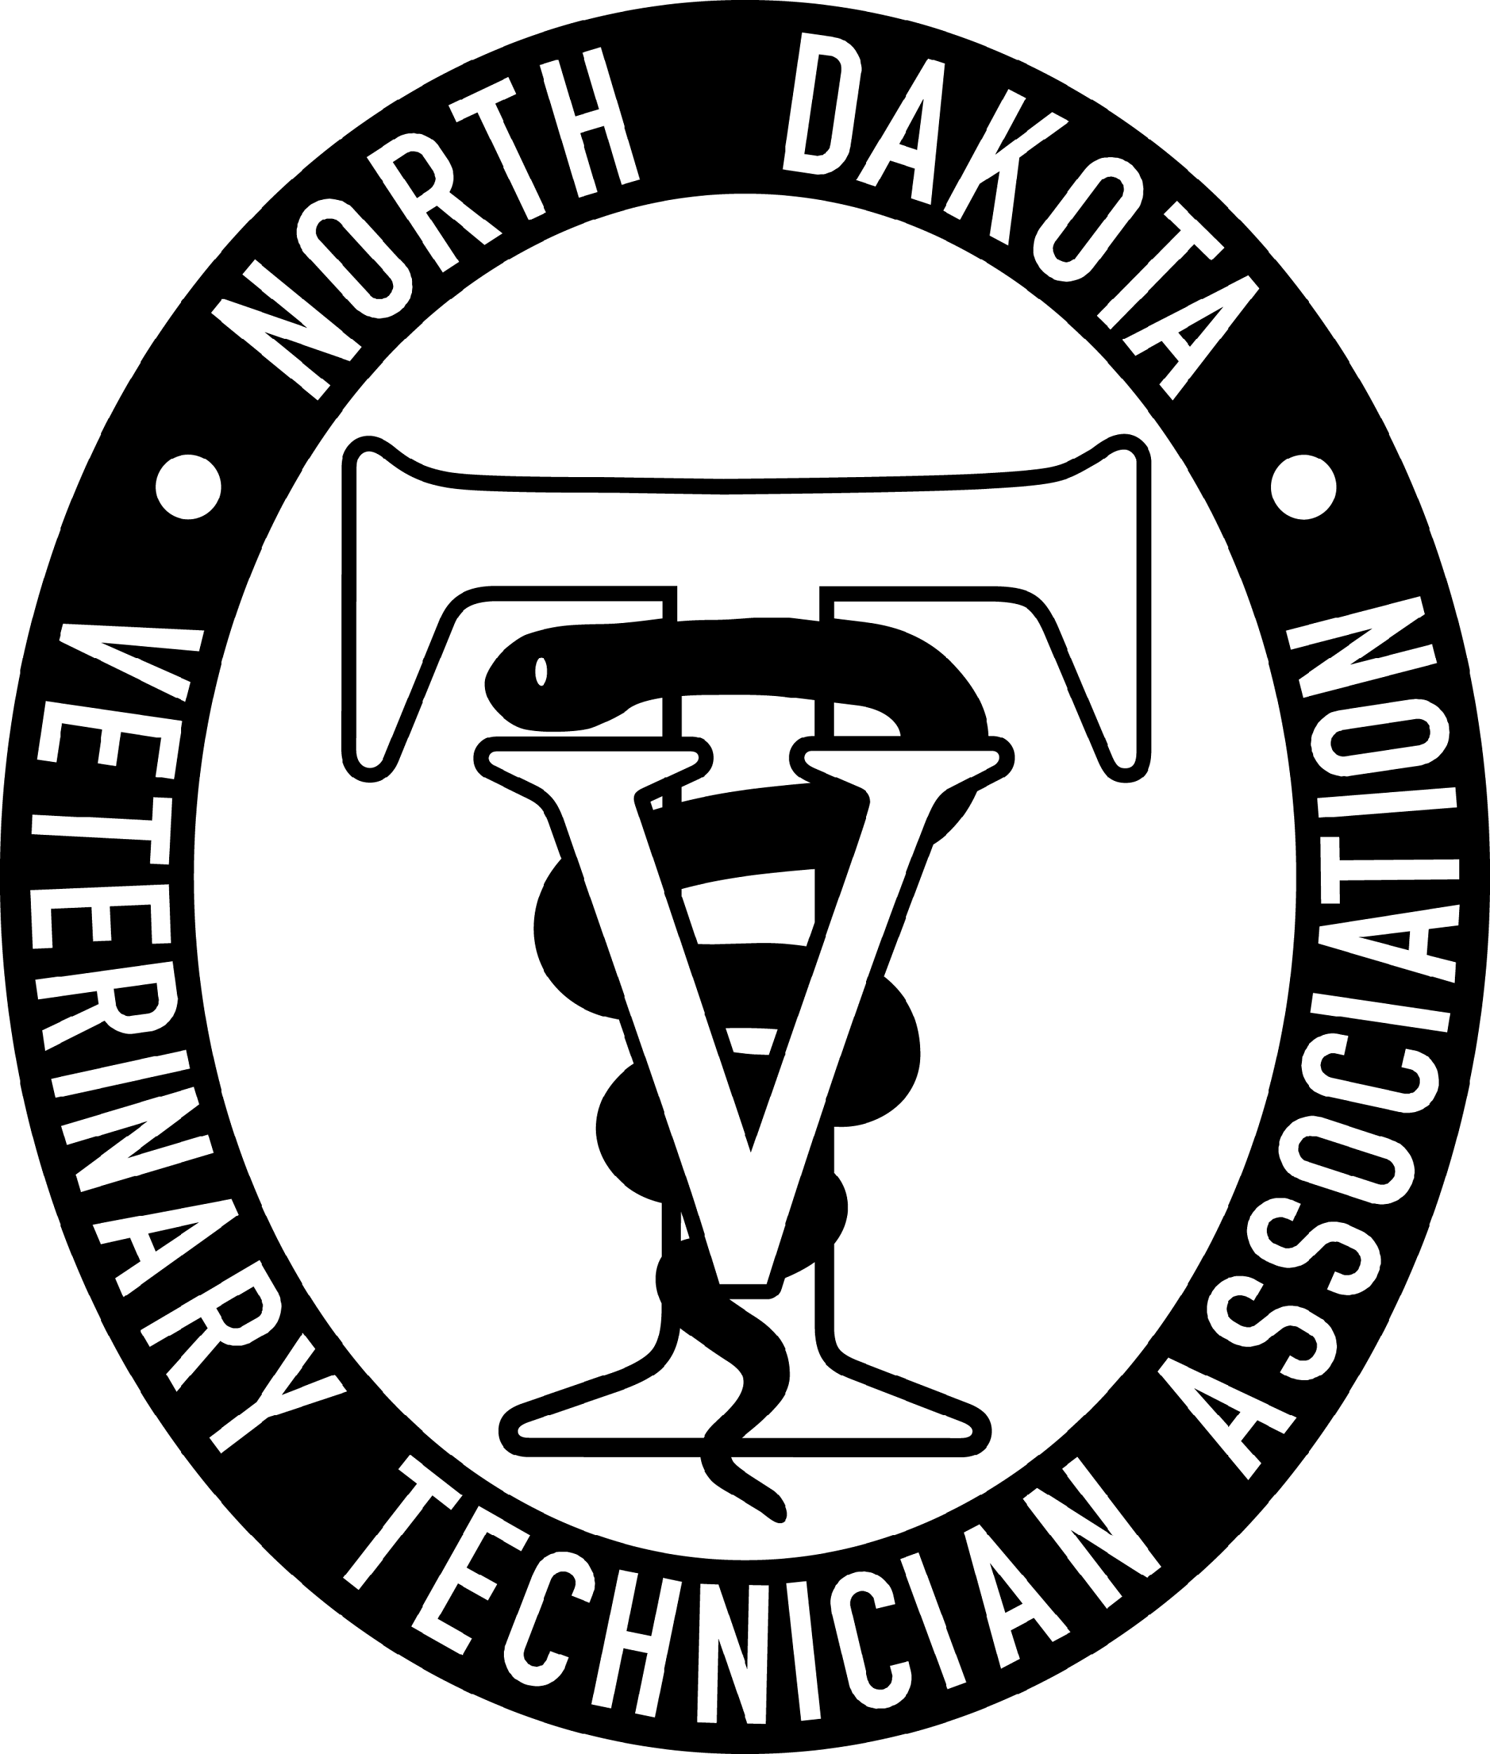

May 14, 2026, NDVTA meeting minutes
Meeting called to order by President Jessica Kuntz at 7:04 pm on May 14, 2026 via Zoom.

Attendance: Jess Kuntz/President, Kelsey Wirt/President Elect, Miranda Langerud/Treasurer, Ashley Hoffmann/Secretary, Liz Bouta/Social Media

Secretary Report: Secretary report for January was submitted by Ashley Hoffmann. No additions or corrections. Kelsey made a motion to approve secretary report, seconded by Randi. Motion passed.

Treasurer Report: Treasurer report for January was submitted by Miranda Langerud. No additions or corrections. Kelsey made a motion to approve treasurer report, seconded by Bree. Motion passed.

Committee Reports:
Scholarship: LuAnn Lee posted to website and NDSU. Post on social media. No submissions yet. Questioned adding an extension on the submission window to correlate easier with the school schedule. Received letters of recommendation and a submission. Discussed extending the submission cutoff date.

Tech of the Year: Posted to the website. Submission requirement possibly needs clarification as the one submission so far is not applicable. 3 eligible submissions.

NDVTA Achievement Award: Updated and posted on the website. No submissions.

PR/NVTW: Nothing new on the calendar to participate in.

Social Media: Continuing scheduled posts on Facebook. Facebook group membership updated.

Website: Website is functioning well.

Practice Act: NDBVME board meetings June 9, August 18, November 10. Kelsey motioned to close the Practice Act committee. Motion passed unanimously.

CE: Speaker list being compiled and CE agreements are filling. Lanyard order to be placed. Finalize speakers by end of July so we can get them cleared with the NDBVME and post to social media and open the form. Reached out to the rabies titer group again to follow-up.

Old Businesss:
- Website inquiries around payment processing and website maintenance. Looking to possibly switch away from Mr. Multimedia and will be meeting with another company.
- Blanket Student Discount – Website updated the prices to include our new blanket $10 discount.
- Rabies Titer – waiting to hear back

New Business:
- Vet Tech verbiage on hospital websites – Considering writing a letter to send to veterinary hospitals to urge them to be conscientious of the license protection verbiage when posting about their employees. Kelsey motioned to close the Practice Act committee. Motion passed unanimously. Rough draft to be started by Kelsey so we can discuss it prior and discuss further at the next meeting.
- Membership quantities – 93 memberships tallied. Considering increasing the early bird discount gap and Non-Member CE cost. Non-Member CE cost to be changed to $280. At the CE meeting we will look to increase the later membership fee to $55. Randi motioned to increase the Non-Member CE actively now to $280. Kelsey seconded. Voted – motion passed unanimously.
- Conference Registration Date – once the speakers are finalized and passed

General membership concerns: None.

Next meeting: June 25, 2026 7pm via Zoom

Adjournment: Kelsey motioned to adjourn the meeting. Randi seconded. Motion passed. The meeting adjourned at 8:01pm

Meeting Minutes submitted by Ashley Hoffmann, LVT - Secretary

