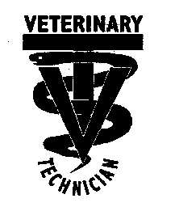
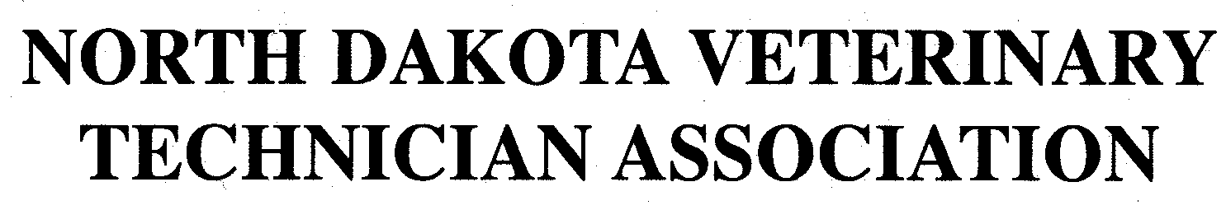
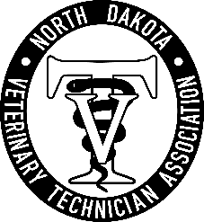

2026 Continued Education Conference
October 9th, 2026

Registration fees: checks payable to North Dakota Veterinary Technician Association

NDVTA Members (if unsure about membership status, please see document on website)- $185.00

NDVTA Non-Members- $275.00

Late Registration postmarked after September 23rd - Additional $75.00

- Current NDVTA paid Member
- Non-NDVTA Member

If you need to verify your membership status, please refer to website (membership tab/2026 paid members)

Return application and remittance by mail to:

Ashley Hoffmann
519 7th Ave E #2
West Fargo, ND 58078

Nominations for President-Elect (2027-2029):________________________________________________

Nominations for Treasurer (2027 - 2028): ___________________________________________________

Personal Information ***Ensure name is how you prefer printed for your CE Certificate***

Name: ________________________________________________________________________________________
Last First Maiden (if applicable)

Address: ______________________________________________________________________________________
Street City State Zip code

Phone number: __________________________ E-mail address: ______________________________________

FOR OFFICE USE ONLY

DATE PD. AMT. PD. TYPE OF PAYMENT CHECK #

